

Mantid Framework
Tessella Project Number 5315
Architectural Design Document

Tessella Support Services plc
E-mail: info@tessella.com | www.tessella.com
Group Head Office: Abingdon
3 Vineyard Chambers, Abingdon, Oxfordshire, OX14 3PX, UK
Tel: +44 (0)1235 555511
Fax: +44 (0)1235 553301

Document Control
This document is under document control. All members of the distribution list will receive updated copies whenever alterations are made.

Contributors
Person | Role | Company | Contribution
Nick Draper | Author | Tessella
Laurent Chapon | Reviewer | Tessella

Document Approval
Person | Role | Company

Distribution
Person | Role | Company
Laurent Chapon | Supervising Officer | Rutherford Appleton Laboratories
Notes Projects Database 5315 |  | Tessella

Revision History
Issue | Author | Date | Description
V1.R1.M0 | Nick Draper | 20-Aug-2007 | 1st version written

References
Ref. | Document | Date | Details and Version
[BC] | Business Case | 11-May-2007 | Version 1.0  http://www.mantidproject.org/images/c/c2/Business_Case_V2.pdf
[DT-UR] | Dunstan Thomas Requirements Specification | 03-Dec-2006 | Version 0.1  http://www.mantidproject.org/images/c/c2/Requirements_RAQuest.pdf
[URD] | User Requirements | 12-Jul-2007 | User Requirements Document - V1.R1.M0
[SRD] | Software Requirements | 12-Jul-2007 | Software Requirements Document - V1.R1.M0
[GAUDI-ADD] | GAUDI Architecture Design Document | 24-Nov-1998 | Version 1.0  http://lhcb-comp.web.cern.ch/lhcb-comp/Meetings/offline/pdf/add.pdf
[UML] | UML Distilled 2nd Edition by M Fowler | 2000 | UML Distilled 2nd Edition by M Fowler, Addison-Wesley, (Tessella ref: 1861)

Table of Contents
1 Introduction 4
Purpose of this Document 4
Scope of this Document 4
Context of this Issue 4
Definition of Terms 4
2 Document Overview and Design Techniques 4
3 System Overview 5
Overview and Context 5
3.2 Architecture Summary 6
3.3 Interfaces Overview 7
3.4 Plug in architecture 7
3.5 Configuration files 8
4 Algorithms and the Algorithm Factory 8
Business Logic Layer 9
5 Text…Sub-system 2 9
User Interface Layer 9
User Interface Process Layer 10
6 Security Sub-system 10
7 Data Access Layer 10
Class Descriptions 10
Data Storage 10
8 Third-Party Software 11
9 Design Scenarios 12
10 System-Wide Features 12
Language 12
On-line help 12
Error-Handling 12
Automated Debugging, Testing and Diagnostics 12
Speed and Capacity 12
Statutory and Regulatory 13
11 Development Environment 13
12 Cross-Reference to Software Requirements 13

Introduction

Sections are labelled [M] for mandatory, [D] for desirable or [A] for ‘if appropriate’.

Purpose of this Document
Defines the overall purpose of this document, i.e. the purpose of this particular version of the ADD (e.g. draft for review etc.), and specifies the intended readership.
This document describes the design of the Mantid Framework.
It is based on the system specified in the Software Requirements Document [SRD]
It will form the basis of the planning of the development phase and will then be updated at the end of the development to act as a guide for maintaining the system.

Scope of this Document
These requirements cover the development of the Mantid Framework and an associated Visualisation tool but not the Analysis applications which will be developed in a later project.
This document will describe the architectural design, detailed design such as methods on individual classes will be documented using DOxygen documentation.

Context of this Issue
This is the first draft of the ADD derived from the SRD and the pilot architecture evaluations and after internal review will be updated and used as a basis for the development of the system.

Definition of Terms
Carefully defines, or provides references to definitions of, terms, acronyms, and abbreviations used in the document.

ADD | The Architectural Design Document (this document), the high level design document for the entire system.
URD | The User Requirements Document, records the users’ requirements for the system.
SRD | The Software Requirements Document, specifies the behaviour of the software system.
API | Application Programming Interface, defines the interface through which two programs may interact.

Document Overview and Design Techniques
This document presents the architecture of the Mantid framework as follows:

Section 3 contains an overview of the architecture of the framework together with a description of its basic functionality.
Section 4 details the architecture of the algorithms and the algorithms factories.
Section 5 describes the service architecture that provides functionality to the algorithms.
Section 6 describes transient data stores and the provided data structure.
Section 7 describes the command line interface.
Section 8 describes the visualization tool.

An object-oriented approach has been used with diagrams produced in UML notation [UML]. All components are modelled with UML class diagrams, sequence diagrams are used to describe the processing of a example operations.

System Overview

Overview and Context

This diagram shows the context of Mantid data analysis framework. The shaded areas will be further detailed in the later sections of this document.
Mantid Framework
Command line interface
Visualization tool
RAW data files
NEXUS data files
Future Data analysis GUI
Instrument log files
API
Standard Algorithms
User Defined Algorithms
Scripting interface

Inputs
The Mantid framework has two main groups of inputs. The first is through the API which will accept commands and requests for data objects from the user interfaces or user written scripts. The second is from various files that contain the data to be processed. Initially supported formats will be RAW files together with their related log files, and NEXUS data files. Further formats may be supported through the plug-in architecture as required.

Major System Functionality
The Mantid framework will provide a skeleton for all of the data reduction and analysis of neutron scattering experiments. The framework provides a structured data repository and a collection of services to make the writing and execution of algorithms as simple as possible. The framework will provide a collection of standard algorithms as well as allowing users to add there own through a user created plug-ins.

Outputs
NEXUS data files will be the main route of outputting data from the application. This has been chosen as it is an open format across the neutron scattering community and it can store the detector and sample information in an extensible way alongside the data. Again the support of output file formats will be extensible through the plug-in architecture. It will also be possible to access the data objects contained within the framework through the API and therefore it will also be possible the extract data through this route.

Architecture Summary
The Mantid framework itself will provide the middle and data tiers for processing neutron scattering data. It is designed to support several different user interfaces including the command line and interactive graphical user interfaces. One of the prime requirements of the design is that it is easily extendable through its plug in architecture to support future data analysis algorithms and different file formats.
As part of the requirements and design effort for this project two candidate architectures were investigated and evaluated for use as the basis of the Mantid framework. The candidate architectures investigated were the GAUDI architecture from the LHCb team at CERN and the other was the architecture developed for the in house PC-COLETTE application used for data analysis for the LOQ instrument. The notes from these investigations can be found on the Mantid project wiki.
As a result of these investigations the architecture will be based on GAUDI [GAUDI-ADD] but with several alterations.
These are primarily:
- The event loop inherent in the architecture will be removed and replaced by a more flexible analysis workflow.
- All references to the ROOT, HBOOK and GEANT4 software packages will be removed, and replaced where necessary by light weight implementations with greater relevance to the neutron scattering community.
- The Converter architecture used for implicit loading and saving of data to persistent stores will be replaced by explicit algorithms specialised to load and persist data.
- A new type of temporary data service will be created called a Managed Data Service that will actively manage the memory use of the objects contained within it.
- Alteration of the Job Options mechanism to split the system wide settings from the algorithms settings and workflow.
The primary packages of the framework are as follows:
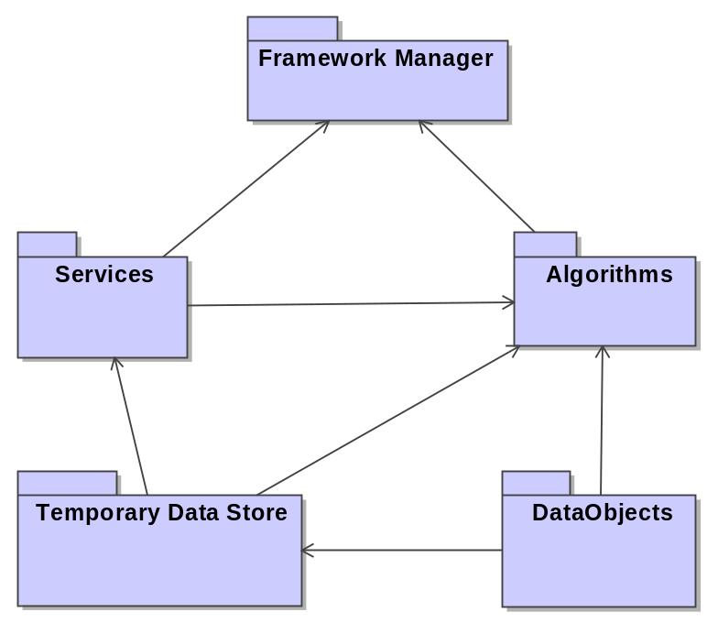

Framework Manager
This is manages the operation of the framework and is responsible for the following tasks.
- Loading any plug-in libraries at startup.
- Initialising the framework and resetting it between analyses.
- Creating and executing algorithms and services as required.
- Coordinating parse mode checks of algorithms commands or scripts. When in parse mode the framework will check the parameter settings of each algorithm by initialising each in turn, but will not actually execute the algorithm.

Algorithms
The algorithms package is where the real data processing occurs in the framework. All the algorithms implement a standard set of generic interfaces which allow specific algorithms to be called without knowing what they do. Algorithms may in turn call further algorithms allowing complex algorithms to be broken down into simpler tasks. This package encapsulates two classes of algorithms.
- Physics Algorithms – Both provided and user created algorithms that act on the data to perform various scientific manipulations.
- Data Handling Algorithms – Algorithms which load and save the data to a persistent store, also algorithms that input or override detector or sample data in the data store.

Services
Services provide useful functionality to the algorithms. This may be directly by the algorithm implicitly calling the service or indirectly through the use of base classes or the Application Manager. This allows the algorithm code to be maintained as simple as possible as well as preventing repeated code. While they are described separately below the transient data stores are services themselves.

Transient Data stores
The transient data stores are the in memory repository of data objects that are used by or created by the algorithms. There will initially be two data stores, a Transient Detector Store, and a Transient Analysis Store. The data is separated based on the expected lifetime. Generally a series of analysis runs will be performed for the same detector. However it is possible that some aspects of a detector will change within an analysis period. These will be described by masks on top of the values in the Transient Detector Store. These will be described further section 6.

Data Objects
The framework will come with a collection of related objects that are designed to describe the data structure used at ISIS. This may be extended further to include data objects to contain standard data structures such as 1D and 2D histograms and ntuples. Users will be able to define there own data objects through the plug-in architecture.

Interfaces Overview
The mantid framework will like GAUDI [GAUDI-ADD] use interfaces to define the interaction between major components. The interfaces for each section will be detailed in the relevant section.

Plug in architecture
The mantid framework will use a plug in architecture that will allow users to extend the framework by defining there own algorithms, data objects or services. This will be based on the existing plug in architecture in GAUDI with the following alterations.
- Any libraries found in the Plugins directories will be loaded by default during the initialisation of the framework.
- The plugin directories will be defined in the configuration file, also an exclusion list of libraries not to load may be defined.

To create a plug-in the user must perform the following steps:
- Create a shared library including the shared header files of the Mantid API.
- Within each new service or algorithm include a call to the macro REGISTER_ALGORITHM or REGISTER_SERVICE as appropriate.
- Compile the library and place it in the plugins directory.
- On restarting the framework the new plugin should be loaded and the user created objects available.

Configuration files
The framework will utilise an xml based configuration file to define various configurable parameters for the operation of the framework. This will define the following parameters.
- The directories to search for Plugins libraries to load.
- The amount of memory the framework is allowed to use.
- The base data directory for loading local data files from.
- The base data output directory.
- The temporary data store location that the framework may use to temporarily move data out of the system memory.
- The list of services to apply to all algorithms by default.
- The message service log file settings.

Algorithms and the Algorithm Factory
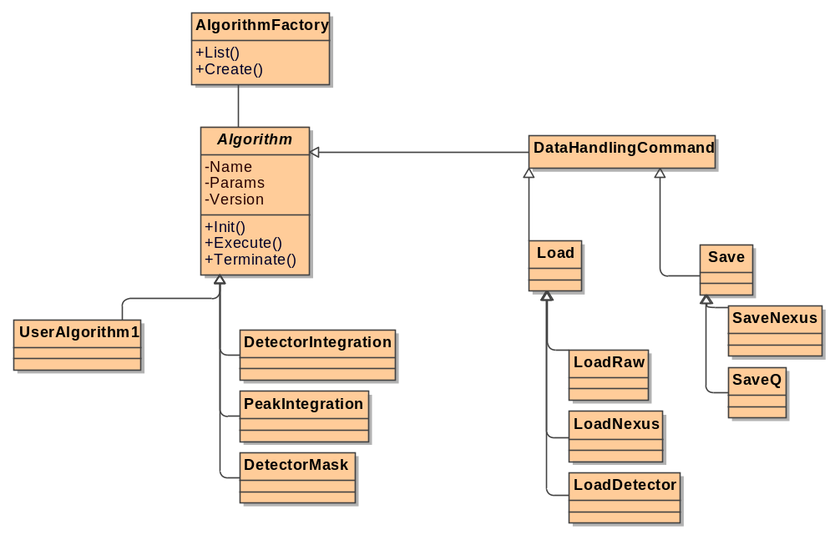

Algorithm Factory
The algorithm factory is responsible for creating instances of algorithm classes on request. This will be used by the framework manager as well as in Algorithms themselves to allow them to create sub-algorithms that can be used to subdivide complex algorithms for simplicity, reuse or performance.
The ‘Abstract Factory’ pattern (“Design Patterns” by E. Gamma et al, Tessella Ref: 2025) will be used to provide a single object creation service for the all of the algorithms and data persistency commands of in the Mantid Framework. During the loading of each plug in library and algorithms contained within them will be registered with the factory using the REGISTER_AGORITHM macro, this will allow user created algorithms to be accessed through the same mechanism. Requests can be either specify the name of an algorithm or by provide both the name and a specific version. Requests not specifying a version will always return the most recent version. Requests that do specify a version will return the version requested, however if a more recent version is available then a warning will be output on the message service.

Interfaces
The AlgorithmFactory class supports the following interface.
- IAlgorithmFactory – To provide access to
  - Add and remove algorithms from the list of available to the factory.
  - List all of the available algorithms
  - Find algorithms based on a partial name string
  - Create an instance of a specified algorithm
  - Check the existence of a specified algorithm.

Algorithm
The algorithm object provides the support structure for all of the real computational code in the Mantid Framework. Any code that the user would like to be executed on data within the framework must be contained in a class that is inherited from the base Algorithm Class.
Algorithms may be executed by the direct request of a user through the Framework Manager API or they may be instantiated and executed by parent algorithms organising several sub algorithms to perform a more complex analysis.
The ‘Command’ pattern (“Design Patterns” by E. Gamma et al, Tessella Ref: 2025) will be used to provide a simple, consistent interface for the all of the algorithms and data persistency commands of in the Mantid Framework. This will allow the framework to handle all algorithms through a single interface IAlgorithm interface.
The algorithm class also provides pre-initialised handles to several of the vital services that may be needed within the implementation of an algorithm. These will include:
- The Service Factory
- The Algorithm Factory
- The Message Service
- The Transient Detector Store
- The Transient Analysis Store
Generally the job of an algorithm will be to take some data from the Transient Analysis Store, alter it in some way and to place the altered data back into the store.

Algorithm options
Each algorithm may have a list of various properties or parameters that are required to configure how the algorithm will function. Examples of this for a simple integration of time bins for 2D spectra would be the max and minimum time bin to include in the integration.
All algorithms will include one these parameters as a minimum (although most will have both).
- InputData – A path within the Temporary Analysis Store to the main input data for the Algorithm.
- OutputData – A path within the Temporary Analysis Store to store the resulting output data of the Algorithm.

Data Handling commands
Data Handling commands such as loading and saving data to and from persistent stores will be defined as implementations of the algorithm class themselves allowing them to be created by the Algorithm Factory and process Algorithm options in the same way as any other algorithm. In addition to loading and saving data to persistent data stores it is envisaged that Data Handling commands will also be provided to add or override detector, sample or sample environment data within the data store.
The data handling commands will be executed just like any other algorithms either by direct execution in response to a request by a user, or by being nested within another algorithm. It is however expected that several of the user interfaces may provide facilities to automate the running of a workflow of analysis algorithms with different input and output files each time, in which case the requisite algorithm options for the load and save commands would be changed for each iteration.
High level Load and Save commands will be included that will implement a ‘Facade’ pattern (“Design Patterns” by E. Gamma et al, Tessella Ref: 2025) will to hide the complexity of selecting the correct command for the common file types. Where possible these high level commands will imply the required specific data handling command based on the file type then pass the processing onto the specific command. This will simplify the data handling of different file types without preventing the users accessing a specific implementation directly should they wish.
Further details of the data access layer will be provided in section 8.

Analysis History
As each algorithm is run it will add a record to the algorithm history of the data it is working on.
??Should this be part of the workspace??

Interfaces
The Algorithm class supports the following interfaces.
- IAglorithm – To provide an interface to control the execution and initialisation of the algorithm.
- IProperty – To provide a consistent mechanism to get and set the internal values to be used by the implementation of an algorithm.

Services
The services encompass a number of components that provide functionality either directly or indirectly to the algorithms. Through the services frequently used functionality can be removed from the ‘physics’ code within the algorithms making them easier to write and maintain.

Service Factory
The service factory is responsible for creating instances of services on request. This will be used by the framework manager and within Algorithms, either by default being called by the base algorithm class or may be called directly in user created algorithms.
The ‘Abstract Factory’ pattern (“Design Patterns” by E. Gamma et al, Tessella Ref: 2025) will be used to provide a single object creation service for the all of the services in the Mantid Framework. During the loading of each plug in library and algorithms contained within them will be registered with the factory using the REGISTER_SERVICE macro, this will allow user created services to be accessed through the same mechanism.

Interfaces
The ServiceFactory class supports the following interface.
- ISvcLocator – To provide access to
  - Get a reference to a service instance.
  - List all of the available services.
  - List all of the active services.
  - Check the existence of a service.
- ISvcManager – To provide access to
  - Add new services to the factory
  - Remove services from the factory

Base Service
Each service will inherit from the base ‘Service’ class. This provides all of the common functionality and exposes three virtual methods that must be defined in the concrete implementation of the service. Each of these is in turn called by a similarly named method prefixed by sys (eg sysInitialize) which is called internally be the service factory.
- Initialize – To setup the service ready for it’s first use.
- Reinitialize – To restart an existing service, for example to remove any accumulated data.
- Finalize – To release any object references after the service is no longer needed.

Interfaces
The Service class supports the following interfaces.
- IService – To provide an interface to control the execution and initialisation of the algorithm.
- IProperty – To provide a consistent mechanism to get and set the internal values to be used by the implementation of an algorithm.

Service Instances

Message Service
This will provide a standard logging and message publishing interface within the framework. Within algorithm or service code strings can be passed to the message service along with a message priority. The service itself will filter the messages that are output from the framework according to their message priority and dispatches them to different output destinations.

ChronStat Service

Auditor Service
??

Random Number Generator Service

Transient Data Store

Transient Data Store

User Interface Layer

User Interface Navigation
Diagram (e.g. UML activity diagram) showing the navigation between major screens if not part of the SRD, and a description of how this navigation will be controlled. This should be supplemented or combined with a description of each principal screen’s purpose (as opposed to appearance), its main controls and the processing behind them. Any style guide to be followed and/or framework used should be referenced.

Examples of how each major screen may look may be best in an appendix or separate document – a ‘paper prototype’.
Text…

Class Descriptions
This could include:
High-level UML package diagram of the main components.
Lower-level UML class diagram of individual components and the relationships between them.
Use of any design patterns should be described e.g. “The ‘Facade’ pattern (“Design Patterns” by E. Gamma et al, Tessella Ref: 2025) will be used to hide the complexities of SubSystemXyz and provide a unified entry point.”
UML state diagrams of any classes that exhibit significant stateful behaviour.
Textual description of important classes, including a formal definition of the class and its external interface (i.e. its public methods and attributes).
Text…

User Interface Process Layer

Class Descriptions
As above…
Text…

Process Layer Logic
Description of any complex processing / logic, including UML sequence/collaboration diagrams if necessary.
Text…
etc.

Security Sub-system
The framework itself provides no security functionality, the data protection is provided by other systems controlling access to the ISIS data archive.
For users external to ISIS the framework will perform operations only on files that have been obtained and can be accessed directly on the file system.
For internal users the framework will also allow files to be retrieved from the ISIS data archive if the required file share is accessible. Internal users will be defined by whether the file share is accessible.

Data Access Layer

Class Descriptions
As above, describing data access API…
Text…

Data Storage

Relational Databases
High-level Entity-Relationship Diagram (Crow’s feet or UML class notation) and description of each entity.
Possibly in addition a low level description including table descriptions and relationships, index policies and entity life histories.
Possibly include a ‘CRUD’ cross-reference showing which operations Create, Read, Update, Delete which entities.
Text…

Drug
Example description of a table.
This table holds all the drugs that can be used by the system

Attribute | Data Type | Description
Drug_ID | Large, unsigned integer | Unique identifier of the drug assigned by the database.
Name | Variable length string (up to 255) | Unique name of the drug.

Files
A high level description of the file contents or a low-level file format specification (or format reference).
Text…

Third-Party Software
Managed correctly, the use of pre-existing software and components as part of a project has the potential to greatly reduce risks and development costs. It is therefore recommended that such use be investigated as part of the system design. In particular, use should be made of the Tessella component registers:
External Component Register (project 3999).
This is a Notes database containing the third party software components Tessella has used on past projects. It is highly recommended that this resource is used, as not only does it provide information on possible components, but also warns of limitation issues and risks involved in using these components.
Internal Component Register (available from the Tessella Intranet).
This is a searchable set of components that Tessella has developed, and that are available for use on other projects.
This section should give a brief description of any third party software (including version) and the justification for using it (including brief reasons for rejecting alternatives – this will allow potentially expensive decisions to be defended should the need arise).
Remember to describe how this software satisfies the requirements in the SRD. (Some compromise may be agreed with the customer, e.g. the component satisfies 90% of what the customer wants for 20% of the cost of writing something equivalent from scratch.)
Points to bear in mind when selecting third-party software:
Try to avoid version 1 of any package, and be wary of initial releases of major versions. These are the most prone to having bugs, and much time can be wasted during development tracking down problems that turn out to be due to the third party software.
If possible, talk to someone who has actually used the package – consider asking the supplier for references if necessary. These users are more likely to give you an unbiased account of any shortcomings than are the suppliers or distributors.
Shareware and freeware may both be used if the need arises, but should be treated with caution. In particular:
If binaries are used, the software must be virus-checked.
The licensing issues must be resolved (e.g. can the freeware be distributed as part of a commercial package? What licensing is required for shareware?).
Support issues must be resolved (how will bugs be resolved, and in what timescale?).
For these reasons, commercially available alternatives are usually to be preferred, although the customer’s view should be sought.
It is also important to describe any licence restrictions.
Finally, consider the need to encapsulate this software (e.g. through the use of the Adapter pattern), to ensure that it is easier to maintain the interface between it and the rest of the system.
Text…

Design Scenarios
Description of how the individual components in the system interact to perform specific scenarios.
The scenarios may be some of the more interesting or complex Use Cases (if these were used during requirements analysis) or complex system interactions, invisible to the user, which may require a sanity check.
A Use Cases Document may have been produced in the user requirements phase [Q2SDEV03]. The aim of this was to elicit requirements and “user goals”. At the design stage it is more useful to consider “system interactions” that explain how the components collaborate to satisfy a particular task in a “start-to-finish” manner. Therefore it is generally best only to use certain interesting or complex parts of use cases in a UCD as a source of scenario descriptions.
The format of this section will be very similar to that of the UCD described in [Q2SDEV03] where the outcome of each design scenario is described along with any preconditions and exceptions. However the description should be followed by an explanation of how the system components achieve the outcome. This should list the components involved and describe their behaviour using text/pseudo-code or using interaction diagrams (UML Sequence or Collaboration diagrams).
Text…

System-Wide Features
A number of design issues apply to the system as a whole, and cannot be isolated to a single component. Such things include:
Text…

Language
English or multi-language support, and how this will be developed. For multi-language support, it is vital to consider how this will be addressed from the outset.
Text…

On-line help
Level, nature (e.g. single file, context-sensitive) and development approach for on-line help.
Text…

Error-Handling
System-wide approach to handling fatal and non-fatal errors, both unexpected and expected, as well as error logging.
Text…

Automated Debugging, Testing and Diagnostics
Approach to built-in debugging / diagnostics.
e.g. “The code will record events with different statuses (error/warning/info) and the application will have an option to select which status events are logged.”
Approach to automated testing.
e.g. “The major methods of classes will have their own automatic self-checking tests using the JUnit framework to enable frequent, extensive unit tests to be run throughout development. Each library will have a test harness user interface to enable it to be executed in isolation.”
Text…

Speed and Capacity
High-level identification of bottlenecks and areas sensitive to capacity problems and the development approach to avoiding them, e.g. client-side or server-side code, choice of database or web server.
This section should also address if and how performance will be measured, e.g. use of profiler tools.
It is usually best to leave decisions over the performance of code in individual methods until development, i.e. write understandable code then profile and tune it, rather than trying to make every line fast and ending up with untuneable code.
Text…

Statutory and Regulatory
If any requirements in this area have been specified, the design must explicitly state how they are satisfied. Otherwise include the following statement:
Tessella is not aware of any Regulatory and Statutory requirements relating to this project although we have not carried out any specific investigation to confirm this. It is the customer’s responsibility to advise us if there are such issues that need to be addressed.

Development Environment
Identification, specification and justification for the development tools used.
Include languages, IDEs, memory checkers, help packages and deployment tools.
Different components may need their own environment. Under these circumstances, this section must document the reasons for the variation, and pay particular attention to how this module will interface with the rest of the system.
If the environment has been specified as part of earlier requirements, a reference to the appropriate document is all that is needed.

Consider what tools may be required for delivery of the system (migrating data, installing applications, configuring applications, installing or upgrading databases).
Consider any customer restrictions on installation (permissions, policies, firewalls etc.)
Text…

Cross-Reference to Software Requirements

This section shows how the design satisfies the software requirements.
SRD Section | ADD Section | Comments

